重 庆 大 学

学 生 实 验 报 告

实验课程名称 JAVA EE程序设计

开课实验室 DS1501

学 院 大数据与软件学院 年级2024专业班 软件工程2班

学 生 姓 名 王昊 学 号20241502

开 课 时 间 2025 至 2026 学年第 2 学期

成 绩
教师签名

大数据与软件学院制

《JAVA EE程序设计》实验报告

开课实验室：DS1502 2021年4月12日
学院 |  | 大数据与软件学院 | 年级、专业、班 |  | 24级软件工程2班 | 姓名 | 王昊 |  | 成绩
课程  名称 |  | JAVA EE程序设计 |  | 实验项目  名 称 | 实验7-8:事件编程、数据库应用编程。 |  |  | 指导教师 |  |  | 鄢萌
教师评 | 教师签名：  2026年 月 日
- 实验目的
实验七：基本掌握使用JAVA来完成基本的图形界面等调试与编程，事件编程调试。
实验八：掌握利用JAVA完成数据库课程中的基本数据记录操作。

二、实验内容

实验内容：
利用图形界面编程，开发简易C/S模式的管理信息系统，题目自拟，实现数据库访问操作。完成SQL SERVER或MYSQL数据库管理系统的安装，配置，JAVA数据库访问环境的配置；完成数据库表的建立，记录插入等；建立用户表，包含用户名、密码字段；利用JAVA实现图形界面，用户登录验证，进入软件运行后，针对某表记录的增、删、改、查操作。

三、使用仪器、材料
JAVA SE JDK 21
Mysql/Sql server

四、实验过程原始记录(数据、图表、计算等)：
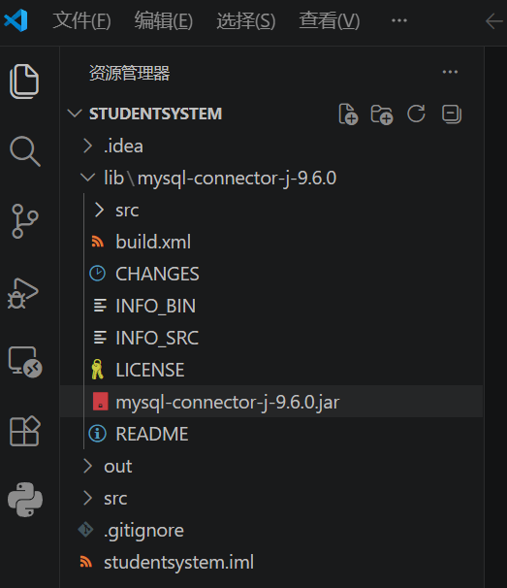
1.完成SQL SERVER或MYSQL数据库管理系统的安装，配置，JAVA数据库访问环境的配置
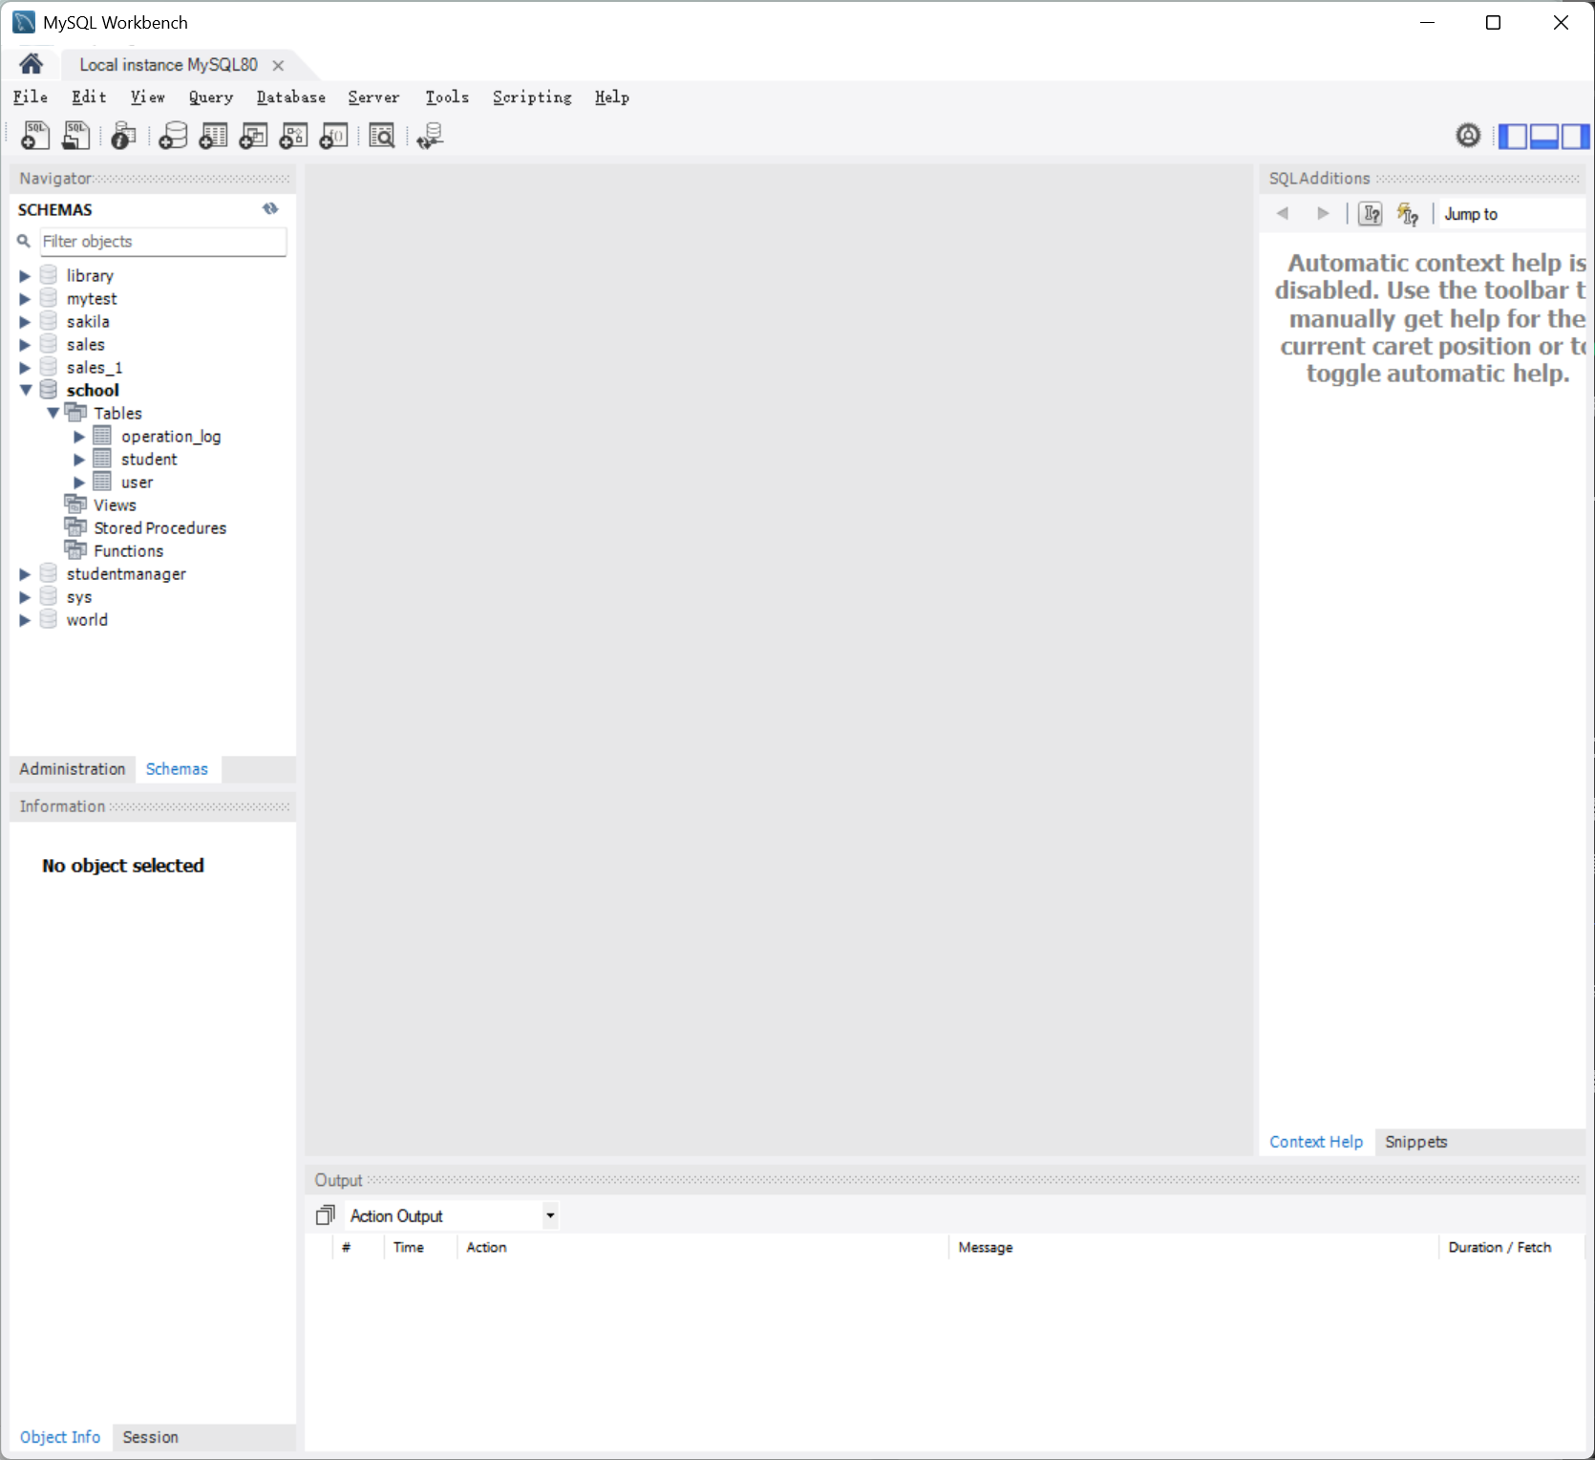

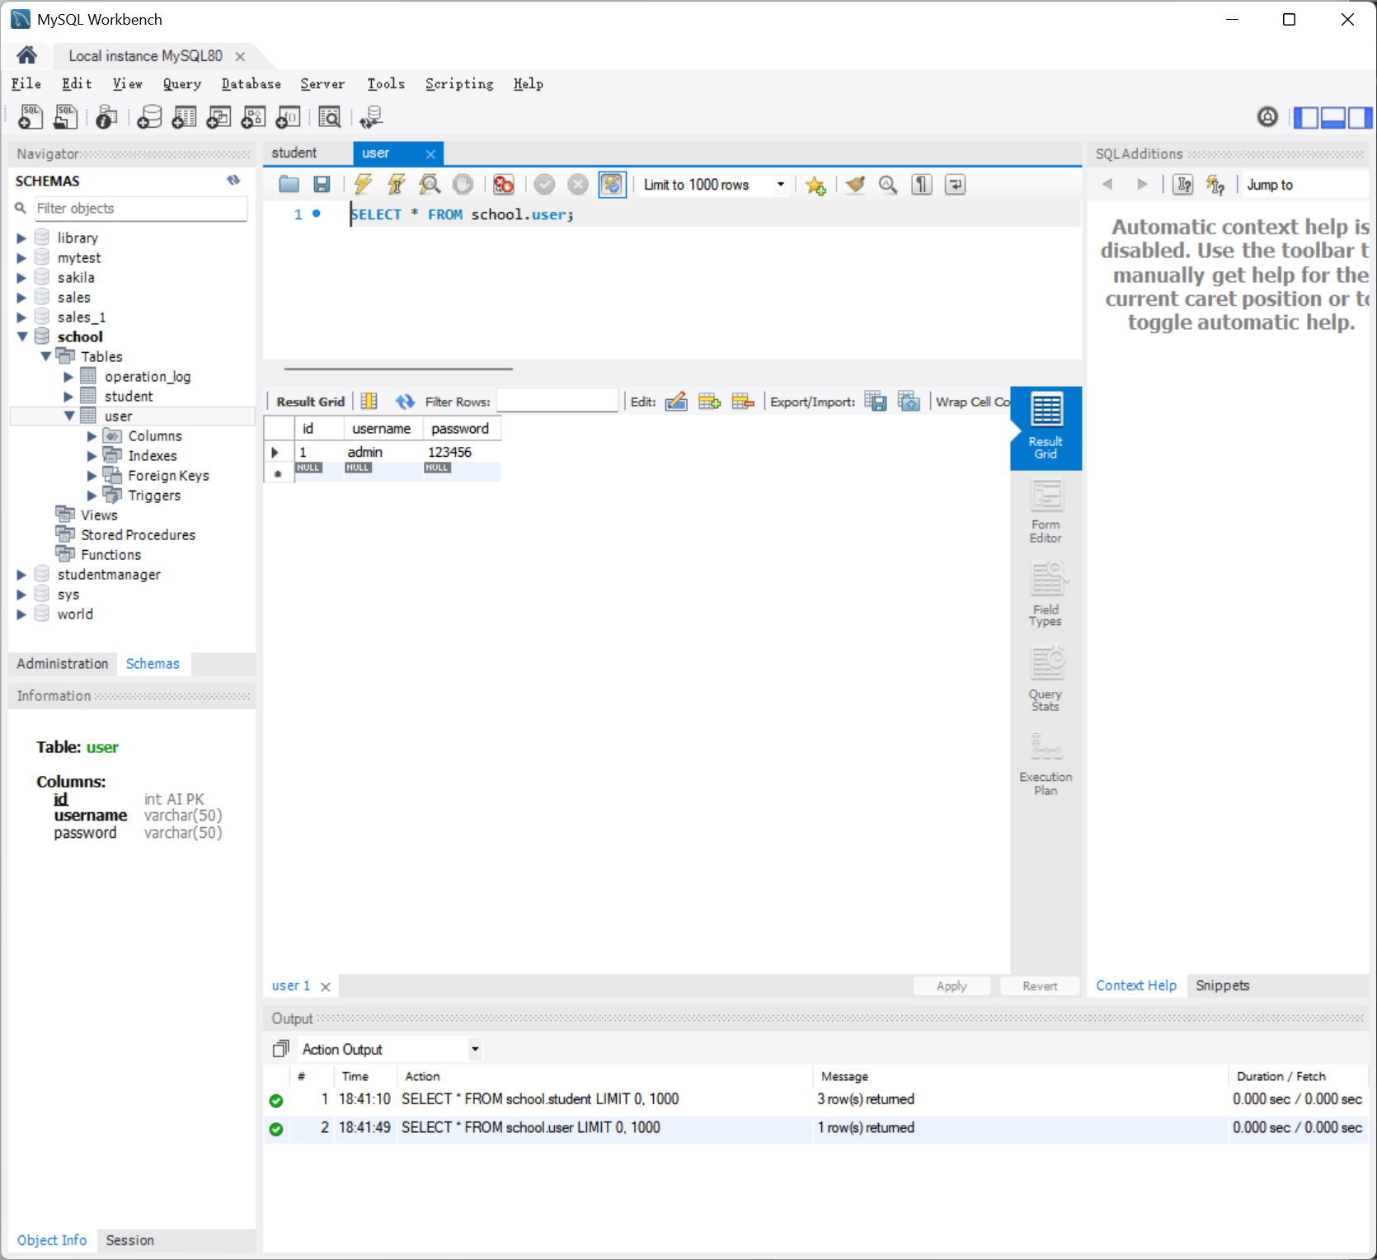
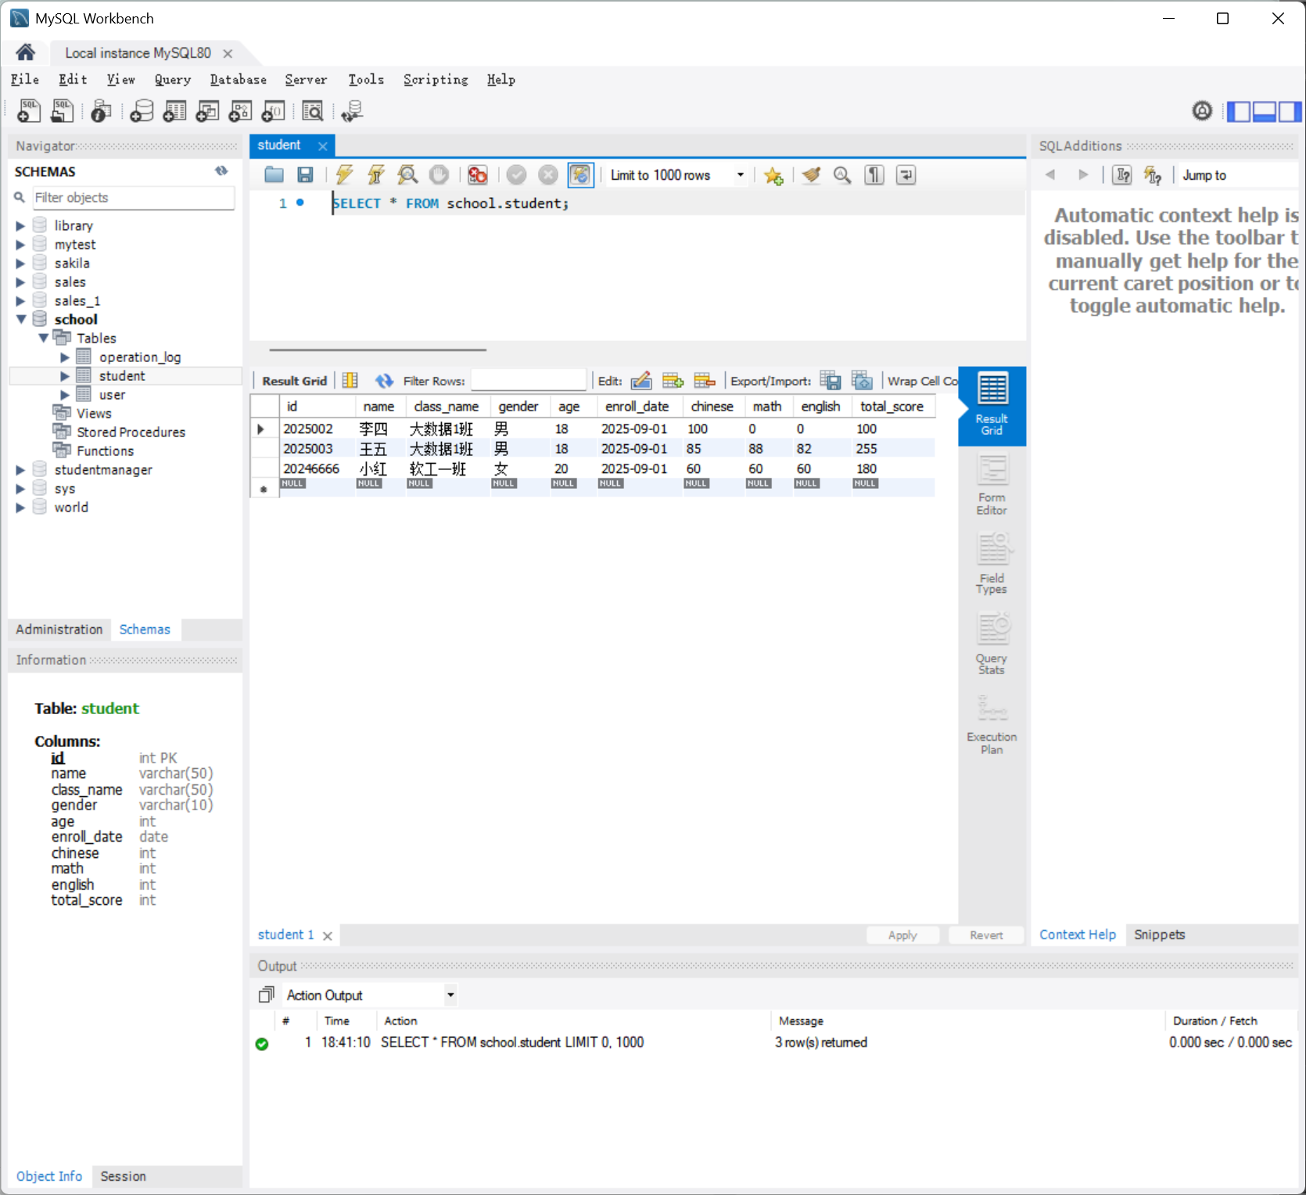
2.完成数据库表的建立，记录插入等；建立用户表，包含用户名、密码字段

3.运行结果
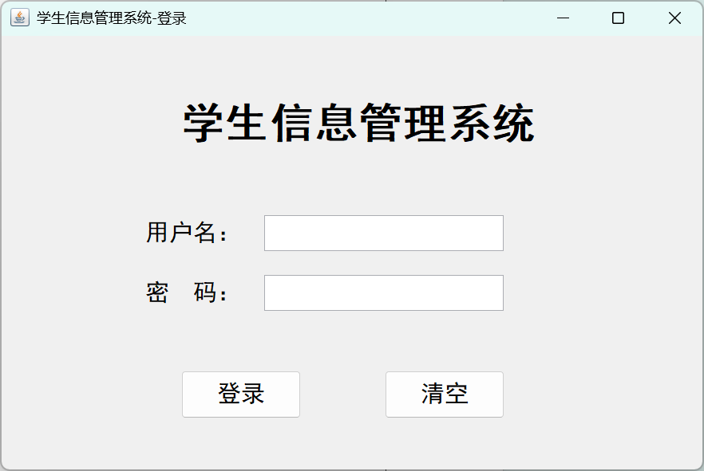
（1）登录界面（运行 Enter.java）

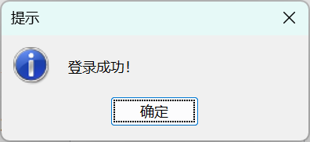
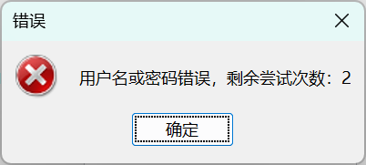

登录成功提示 输入错误（满三次程序直接退出）

（2）主界面（StudentManagement.java）
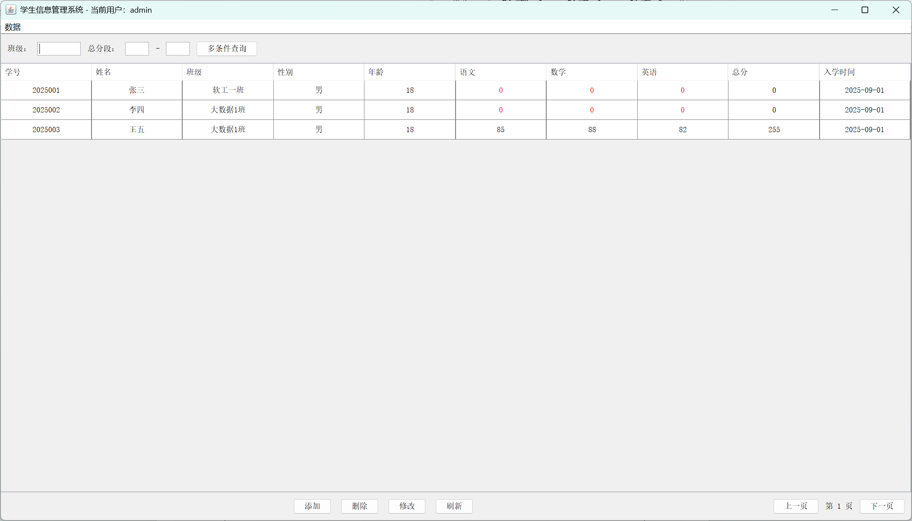

（3）添加学生功能
添加学生小红 添加成功
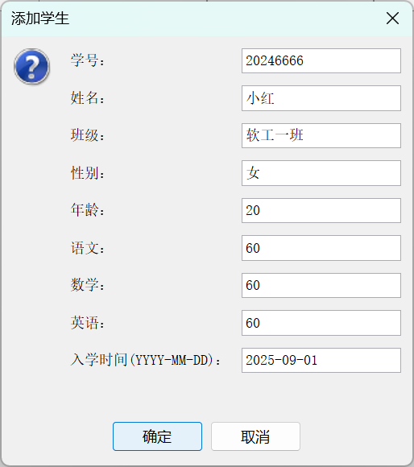
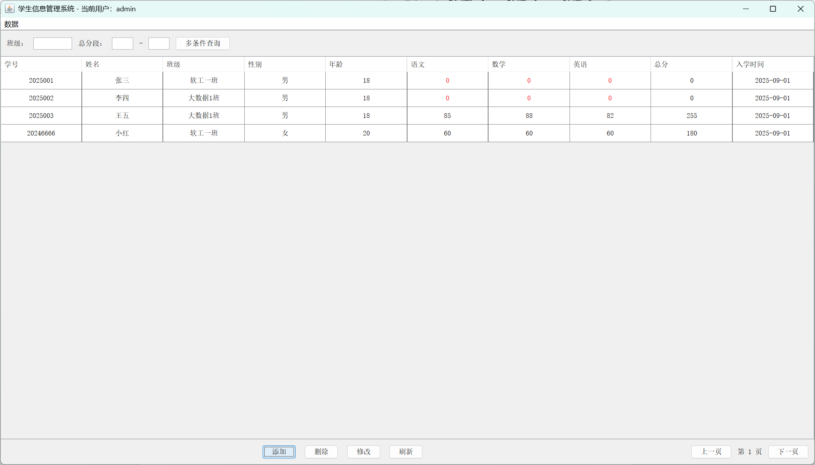

- 删除学生功能
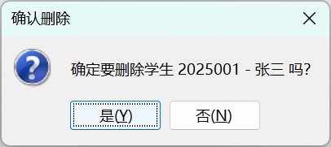
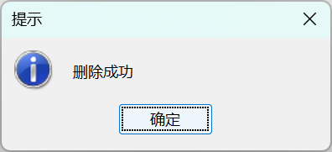
删除学生张三

- 修改学生信息功能
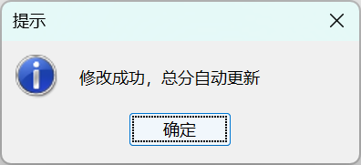
修改李四语文成绩
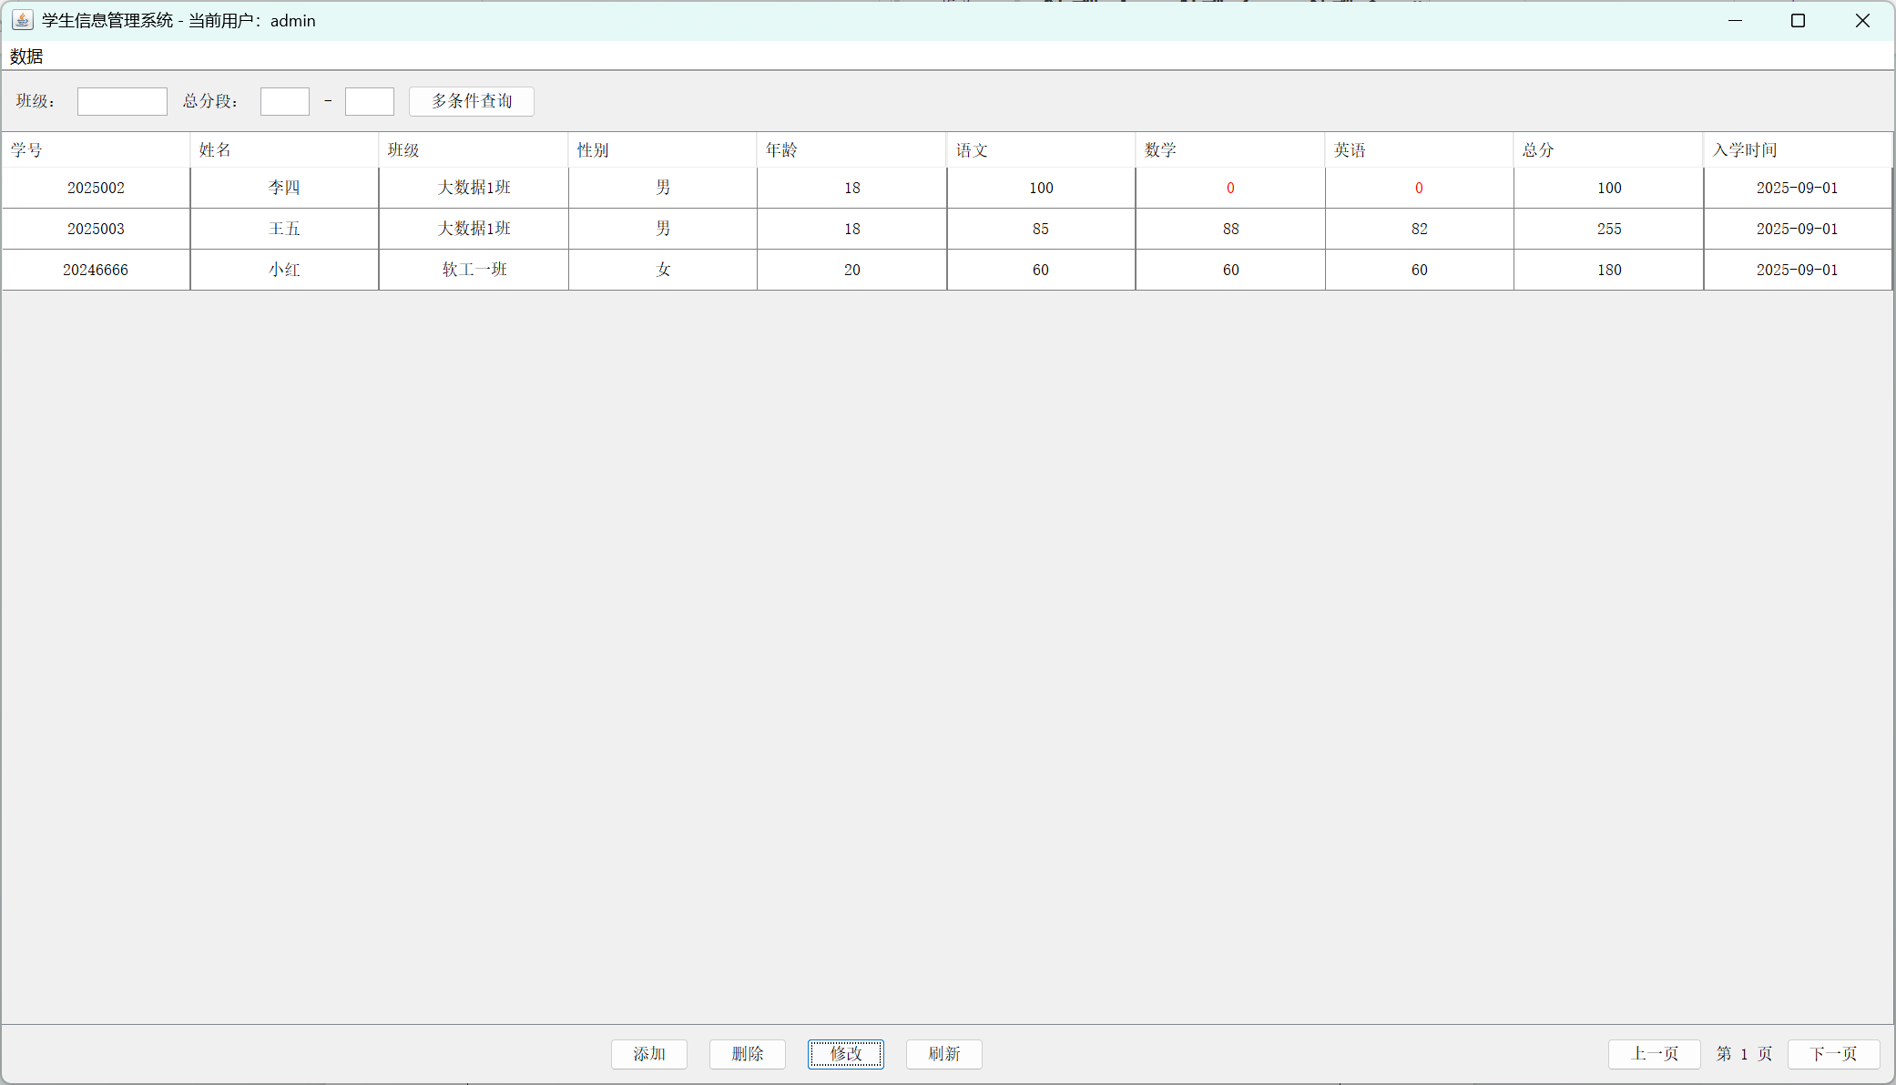

- 查询学生信息功能
可通过班级，学号，分数段条件单独或者联合查询
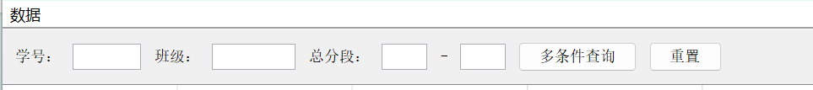

根据学号查询到学生小红
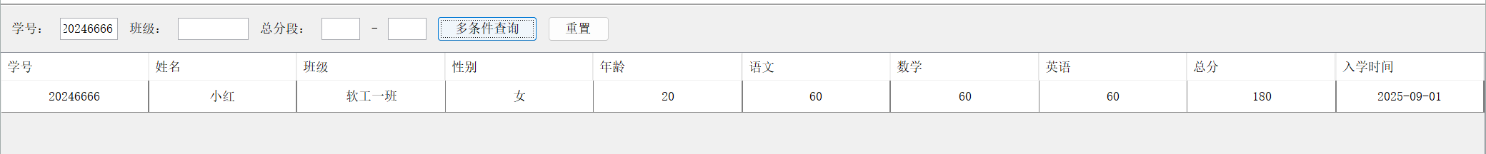

（7）对于成绩低于 60 分的学生，分数会变为红色

- 核心代码
- Enter.java
import javax.swing.*;

public class Enter {
public static void main(String[] args) {

SwingUtilities.invokeLater(() -> {
try {
// 设置系统外观，和Windows风格一致
UIManager.setLookAndFeel(UIManager.getSystemLookAndFeelClassName());
} catch (Exception e) {
e.printStackTrace();
}
// 启动登录窗口
new WindowEnter();
});
}
}

- WindowEnter.java
import javax.swing.*;
import java.awt.*;
import java.awt.event.ActionEvent;
import java.sql.Connection;
import java.sql.PreparedStatement;
import java.sql.ResultSet;

public class WindowEnter extends JFrame {
private JTextField usernameField;
private JPasswordField passwordField;
private int failCount = 0;
private static final int MAX_FAIL = 3;

public WindowEnter() {
initUI();
setTitle("学生信息管理系统-登录");
setSize(600, 400);
setDefaultCloseOperation(JFrame.EXIT_ON_CLOSE);
setLocationRelativeTo(null);
setVisible(true);
}

private void initUI() {
JPanel panel = new JPanel(null);

JLabel titleLabel = new JLabel("学生信息管理系统");
titleLabel.setFont(new Font("黑体", Font.BOLD, 36));
titleLabel.setBounds(150, 50, 300, 50);
panel.add(titleLabel);

JLabel userLabel = new JLabel("用户名：");
userLabel.setFont(new Font("黑体", Font.PLAIN, 20));
userLabel.setBounds(120, 150, 100, 30);
usernameField = new JTextField();
usernameField.setFont(new Font("黑体", Font.PLAIN, 20));
usernameField.setBounds(220, 150, 200, 30);
panel.add(userLabel);
panel.add(usernameField);

JLabel passLabel = new JLabel("密 码：");
passLabel.setFont(new Font("黑体", Font.PLAIN, 20));
passLabel.setBounds(120, 200, 100, 30);
passwordField = new JPasswordField();
passwordField.setFont(new Font("黑体", Font.PLAIN, 20));
passwordField.setBounds(220, 200, 200, 30);
panel.add(passLabel);
panel.add(passwordField);

JButton loginBtn = new JButton("登录");
loginBtn.setFont(new Font("黑体", Font.PLAIN, 20));
loginBtn.setBounds(150, 280, 100, 40);
JButton clearBtn = new JButton("清空");
clearBtn.setFont(new Font("黑体", Font.PLAIN, 20));
clearBtn.setBounds(320, 280, 100, 40);
panel.add(loginBtn);
panel.add(clearBtn);

loginBtn.addActionListener(this::login);
clearBtn.addActionListener(e -> {
usernameField.setText("");
passwordField.setText("");
});

add(panel);
}

private void login(ActionEvent e) {
if (failCount >= MAX_FAIL) {
JOptionPane.showMessageDialog(this, "登录失败次数过多，程序退出", "错误", JOptionPane.ERROR_MESSAGE);
System.exit(0);
return;
}

String username = usernameField.getText().trim();
String password = new String(passwordField.getPassword()).trim();

if (username.isEmpty() || password.isEmpty()) {
JOptionPane.showMessageDialog(this, "用户名或密码不能为空", "错误", JOptionPane.ERROR_MESSAGE);
return;
}

Connection conn = null;
PreparedStatement stmt = null;
ResultSet rs = null;

try {
conn = DBUtil.getConnection();
String sql = "SELECT * FROM user WHERE username=? AND password=?";
stmt = conn.prepareStatement(sql);
stmt.setString(1, username);
stmt.setString(2, password);
rs = stmt.executeQuery();

if (rs.next()) {
JOptionPane.showMessageDialog(this, "登录成功！", "提示", JOptionPane.INFORMATION_MESSAGE);
dispose();
new StudentManagementSystem(username);
} else {
failCount++;
JOptionPane.showMessageDialog(this, "用户名或密码错误，剩余尝试次数：" + (MAX_FAIL - failCount), "错误", JOptionPane.ERROR_MESSAGE);
}
} catch (Exception ex) {
JOptionPane.showMessageDialog(this, "登录失败：" + ex.getMessage(), "错误", JOptionPane.ERROR_MESSAGE);
} finally {
DBUtil.close(conn, stmt, rs);
}
}
}

- StudentManagementSystem.java
import javax.swing.*;
import javax.swing.table.DefaultTableCellRenderer;
import javax.swing.table.DefaultTableModel;
import java.awt.*;
import java.awt.event.ActionEvent;
import java.sql.Connection;
import java.sql.PreparedStatement;
import java.sql.ResultSet;

public class StudentManagementSystem extends JFrame {
private JTable table;
private DefaultTableModel tableModel;
private int currentPage = 1;
private int pageSize = 10;
private String currentUser;

public StudentManagementSystem(String username) {
this.currentUser = username;
initUI();
loadData();
setTitle("学生信息管理系统 - 当前用户：" + username);
setSize(1400, 800);
setDefaultCloseOperation(JFrame.EXIT_ON_CLOSE);
setLocationRelativeTo(null);
setVisible(true);
}

private void initUI() {
// 菜单栏
JMenuBar menuBar = new JMenuBar();
JMenu dataMenu = new JMenu("数据");
JMenuItem statsItem = new JMenuItem("成绩统计");
JMenuItem logItem = new JMenuItem("操作日志");
dataMenu.add(statsItem);
dataMenu.add(logItem);
menuBar.add(dataMenu);
setJMenuBar(menuBar);

// 主面板
JPanel mainPanel = new JPanel(new BorderLayout());

// 顶部多条件查询面板（新增学号查询+重置按钮）
JPanel searchPanel = new JPanel(new FlowLayout(FlowLayout.LEFT, 10, 10));
searchPanel.add(new JLabel("学号："));
JTextField idField = new JTextField(8);
searchPanel.add(idField);
searchPanel.add(new JLabel("班级："));
JTextField classField = new JTextField(10);
searchPanel.add(classField);
searchPanel.add(new JLabel("总分段："));
JTextField minScoreField = new JTextField(5);
searchPanel.add(minScoreField);
searchPanel.add(new JLabel("-"));
JTextField maxScoreField = new JTextField(5);
searchPanel.add(maxScoreField);
JButton searchBtn = new JButton("多条件查询");
JButton resetBtn = new JButton("重置");
searchPanel.add(searchBtn);
searchPanel.add(resetBtn);
mainPanel.add(searchPanel, BorderLayout.NORTH);

// 表格
String[] columns = {"学号", "姓名", "班级", "性别", "年龄", "语文", "数学", "英语", "总分", "入学时间"};
tableModel = new DefaultTableModel(columns, 0) {
@Override
public boolean isCellEditable(int row, int column) {
return false;
}
};
table = new JTable(tableModel);
table.setSelectionMode(ListSelectionModel.SINGLE_SELECTION);
table.setRowHeight(30);

// 所有列居中，科目列应用标红渲染器
DefaultTableCellRenderer centerRenderer = new DefaultTableCellRenderer();
centerRenderer.setHorizontalAlignment(SwingConstants.CENTER);
for (int i = 0; i < table.getColumnCount(); i++) {
table.getColumnModel().getColumn(i).setCellRenderer(centerRenderer);
}
table.getColumnModel().getColumn(5).setCellRenderer(new ChangePointFeature.ScoreRenderer());
table.getColumnModel().getColumn(6).setCellRenderer(new ChangePointFeature.ScoreRenderer());
table.getColumnModel().getColumn(7).setCellRenderer(new ChangePointFeature.ScoreRenderer());

JScrollPane scrollPane = new JScrollPane(table);
mainPanel.add(scrollPane, BorderLayout.CENTER);

// 底部按钮+分页面板
JPanel bottomPanel = new JPanel(new BorderLayout());
JPanel btnPanel = new JPanel(new FlowLayout(FlowLayout.CENTER, 15, 10));
JButton addBtn = new JButton("添加");
JButton deleteBtn = new JButton("删除");
JButton updateBtn = new JButton("修改");
JButton refreshBtn = new JButton("刷新");
btnPanel.add(addBtn);
btnPanel.add(deleteBtn);
btnPanel.add(updateBtn);
btnPanel.add(refreshBtn);
bottomPanel.add(btnPanel, BorderLayout.CENTER);

JPanel pagePanel = new JPanel(new FlowLayout(FlowLayout.RIGHT, 10, 10));
JButton prevBtn = new JButton("上一页");
JLabel pageLabel = new JLabel("第 " + currentPage + " 页");
JButton nextBtn = new JButton("下一页");
pagePanel.add(prevBtn);
pagePanel.add(pageLabel);
pagePanel.add(nextBtn);
bottomPanel.add(pagePanel, BorderLayout.EAST);
mainPanel.add(bottomPanel, BorderLayout.SOUTH);

// 事件绑定
addBtn.addActionListener(this::addStudent);
deleteBtn.addActionListener(this::deleteStudent);
updateBtn.addActionListener(this::updateStudent);
refreshBtn.addActionListener(e -> loadData());
prevBtn.addActionListener(e -> {
if (currentPage > 1) {
currentPage--;
loadData();
pageLabel.setText("第 " + currentPage + " 页");
}
});
nextBtn.addActionListener(e -> {
currentPage++;
loadData();
pageLabel.setText("第 " + currentPage + " 页");
});
// 多条件查询（支持学号+班级+总分段）
searchBtn.addActionListener(e -> multiConditionSearch(
idField.getText(),
classField.getText(),
minScoreField.getText(),
maxScoreField.getText()
));
// 重置按钮
resetBtn.addActionListener(e -> {
idField.setText("");
classField.setText("");
minScoreField.setText("");
maxScoreField.setText("");
loadData();
});
statsItem.addActionListener(e -> showStats());
logItem.addActionListener(e -> showLogs());

add(mainPanel);
}

// 加载分页数据
private void loadData() {
tableModel.setRowCount(0);
Connection conn = null;
PreparedStatement stmt = null;
ResultSet rs = null;

try {
conn = DBUtil.getConnection();
String sql = "SELECT * FROM student ORDER BY id LIMIT ? OFFSET ?";
stmt = conn.prepareStatement(sql);
stmt.setInt(1, pageSize);
stmt.setInt(2, (currentPage - 1) * pageSize);
rs = stmt.executeQuery();

while (rs.next()) {
Object[] row = {
rs.getInt("id"),
rs.getString("name"),
rs.getString("class_name"),
rs.getString("gender"),
rs.getInt("age"),
rs.getInt("chinese"),
rs.getInt("math"),
rs.getInt("english"),
rs.getInt("total_score"),
rs.getDate("enroll_date")
};
tableModel.addRow(row);
}
} catch (Exception e) {
JOptionPane.showMessageDialog(this, "数据加载失败：" + e.getMessage(), "错误", JOptionPane.ERROR_MESSAGE);
} finally {
DBUtil.close(conn, stmt, rs);
}
}

// 添加学生
private void addStudent(ActionEvent e) {
JPanel panel = new JPanel(new GridLayout(10, 2, 10, 10));
JTextField idField = new JTextField();
JTextField nameField = new JTextField();
JTextField classField = new JTextField("大数据1班");
JTextField genderField = new JTextField("男");
JTextField ageField = new JTextField("18");
JTextField chineseField = new JTextField("0");
JTextField mathField = new JTextField("0");
JTextField englishField = new JTextField("0");
JTextField dateField = new JTextField("2025-09-01");

panel.add(new JLabel("学号："));
panel.add(idField);
panel.add(new JLabel("姓名："));
panel.add(nameField);
panel.add(new JLabel("班级："));
panel.add(classField);
panel.add(new JLabel("性别："));
panel.add(genderField);
panel.add(new JLabel("年龄："));
panel.add(ageField);
panel.add(new JLabel("语文："));
panel.add(chineseField);
panel.add(new JLabel("数学："));
panel.add(mathField);
panel.add(new JLabel("英语："));
panel.add(englishField);
panel.add(new JLabel("入学时间(YYYY-MM-DD)："));
panel.add(dateField);

int result = JOptionPane.showConfirmDialog(this, panel, "添加学生", JOptionPane.OK_CANCEL_OPTION);
if (result == JOptionPane.OK_OPTION) {
try {
int id = Integer.parseInt(idField.getText().trim());
String name = nameField.getText().trim();
String className = classField.getText().trim();
String gender = genderField.getText().trim();
int age = Integer.parseInt(ageField.getText().trim());
int chinese = Integer.parseInt(chineseField.getText().trim());
int math = Integer.parseInt(mathField.getText().trim());
int english = Integer.parseInt(englishField.getText().trim());
String date = dateField.getText().trim();

if (name.isEmpty()) {
JOptionPane.showMessageDialog(this, "姓名不能为空", "错误", JOptionPane.ERROR_MESSAGE);
return;
}

Connection conn = DBUtil.getConnection();
String sql = "INSERT INTO student (id, name, class_name, gender, age, chinese, math, english, enroll_date) VALUES (?, ?, ?, ?, ?, ?, ?, ?, ?)";
PreparedStatement stmt = conn.prepareStatement(sql);
stmt.setInt(1, id);
stmt.setString(2, name);
stmt.setString(3, className);
stmt.setString(4, gender);
stmt.setInt(5, age);
stmt.setInt(6, chinese);
stmt.setInt(7, math);
stmt.setInt(8, english);
stmt.setString(9, date);
stmt.executeUpdate();

JOptionPane.showMessageDialog(this, "添加成功，总分自动计算", "提示", JOptionPane.INFORMATION_MESSAGE);
DBUtil.log(currentUser, "添加学生：" + id + " - " + name);
loadData();
DBUtil.close(conn, stmt, null);
} catch (NumberFormatException ex) {
JOptionPane.showMessageDialog(this, "学号/年龄/分数必须是数字", "错误", JOptionPane.ERROR_MESSAGE);
} catch (Exception ex) {
if (ex.getMessage().contains("Duplicate entry")) {
JOptionPane.showMessageDialog(this, "学号已存在", "错误", JOptionPane.ERROR_MESSAGE);
} else {
JOptionPane.showMessageDialog(this, "添加失败：" + ex.getMessage(), "错误", JOptionPane.ERROR_MESSAGE);
}
}
}
}

// 删除学生
private void deleteStudent(ActionEvent e) {
int selectedRow = table.getSelectedRow();
if (selectedRow == -1) {
JOptionPane.showMessageDialog(this, "请先选择要删除的学生", "提示", JOptionPane.WARNING_MESSAGE);
return;
}

int id = (int) tableModel.getValueAt(selectedRow, 0);
String name = (String) tableModel.getValueAt(selectedRow, 1);

int confirm = JOptionPane.showConfirmDialog(this,
"确定要删除学生 " + id + " - " + name + " 吗？",
"确认删除", JOptionPane.YES_NO_OPTION);

if (confirm == JOptionPane.YES_OPTION) {
try (Connection conn = DBUtil.getConnection();
PreparedStatement stmt = conn.prepareStatement("DELETE FROM student WHERE id=?")) {
stmt.setInt(1, id);
stmt.executeUpdate();
JOptionPane.showMessageDialog(this, "删除成功", "提示", JOptionPane.INFORMATION_MESSAGE);
DBUtil.log(currentUser, "删除学生：" + id + " - " + name);
loadData();
} catch (Exception ex) {
JOptionPane.showMessageDialog(this, "删除失败：" + ex.getMessage(), "错误", JOptionPane.ERROR_MESSAGE);
}
}
}

// 修改学生
private void updateStudent(ActionEvent e) {
int selectedRow = table.getSelectedRow();
if (selectedRow == -1) {
JOptionPane.showMessageDialog(this, "请先选择要修改的学生", "提示", JOptionPane.WARNING_MESSAGE);
return;
}

int oldId = (int) tableModel.getValueAt(selectedRow, 0);
String oldName = (String) tableModel.getValueAt(selectedRow, 1);
String oldClass = (String) tableModel.getValueAt(selectedRow, 2);
String oldGender = (String) tableModel.getValueAt(selectedRow, 3);
int oldAge = (int) tableModel.getValueAt(selectedRow, 4);
int oldChinese = (int) tableModel.getValueAt(selectedRow, 5);
int oldMath = (int) tableModel.getValueAt(selectedRow, 6);
int oldEnglish = (int) tableModel.getValueAt(selectedRow, 7);
String oldDate = tableModel.getValueAt(selectedRow, 9).toString();

JPanel panel = new JPanel(new GridLayout(10, 2, 10, 10));
JTextField idField = new JTextField(String.valueOf(oldId));
JTextField nameField = new JTextField(oldName);
JTextField classField = new JTextField(oldClass);
JTextField genderField = new JTextField(oldGender);
JTextField ageField = new JTextField(String.valueOf(oldAge));
JTextField chineseField = new JTextField(String.valueOf(oldChinese));
JTextField mathField = new JTextField(String.valueOf(oldMath));
JTextField englishField = new JTextField(String.valueOf(oldEnglish));
JTextField dateField = new JTextField(oldDate);

panel.add(new JLabel("学号："));
panel.add(idField);
panel.add(new JLabel("姓名："));
panel.add(nameField);
panel.add(new JLabel("班级："));
panel.add(classField);
panel.add(new JLabel("性别："));
panel.add(genderField);
panel.add(new JLabel("年龄："));
panel.add(ageField);
panel.add(new JLabel("语文："));
panel.add(chineseField);
panel.add(new JLabel("数学："));
panel.add(mathField);
panel.add(new JLabel("英语："));
panel.add(englishField);
panel.add(new JLabel("入学时间(YYYY-MM-DD)："));
panel.add(dateField);

int result = JOptionPane.showConfirmDialog(this, panel, "修改学生信息", JOptionPane.OK_CANCEL_OPTION);
if (result == JOptionPane.OK_OPTION) {
try {
int newId = Integer.parseInt(idField.getText().trim());
String newName = nameField.getText().trim();
String newClass = classField.getText().trim();
String newGender = genderField.getText().trim();
int newAge = Integer.parseInt(ageField.getText().trim());
int newChinese = Integer.parseInt(chineseField.getText().trim());
int newMath = Integer.parseInt(mathField.getText().trim());
int newEnglish = Integer.parseInt(englishField.getText().trim());
String newDate = dateField.getText().trim();

if (newName.isEmpty()) {
JOptionPane.showMessageDialog(this, "姓名不能为空", "错误", JOptionPane.ERROR_MESSAGE);
return;
}

try (Connection conn = DBUtil.getConnection()) {
if (newId != oldId) {
PreparedStatement checkStmt = conn.prepareStatement("SELECT id FROM student WHERE id=?");
checkStmt.setInt(1, newId);
ResultSet rs = checkStmt.executeQuery();
if (rs.next()) {
JOptionPane.showMessageDialog(this, "学号已存在", "错误", JOptionPane.ERROR_MESSAGE);
return;
}
}

String sql = "UPDATE student SET id=?, name=?, class_name=?, gender=?, age=?, chinese=?, math=?, english=?, enroll_date=? WHERE id=?";
PreparedStatement stmt = conn.prepareStatement(sql);
stmt.setInt(1, newId);
stmt.setString(2, newName);
stmt.setString(3, newClass);
stmt.setString(4, newGender);
stmt.setInt(5, newAge);
stmt.setInt(6, newChinese);
stmt.setInt(7, newMath);
stmt.setInt(8, newEnglish);
stmt.setString(9, newDate);
stmt.setInt(10, oldId);
stmt.executeUpdate();

JOptionPane.showMessageDialog(this, "修改成功，总分自动更新", "提示", JOptionPane.INFORMATION_MESSAGE);
DBUtil.log(currentUser, "修改学生：" + newId + " - " + newName);
loadData();
}
} catch (NumberFormatException ex) {
JOptionPane.showMessageDialog(this, "学号/年龄/分数必须是数字", "错误", JOptionPane.ERROR_MESSAGE);
} catch (Exception ex) {
JOptionPane.showMessageDialog(this, "修改失败：" + ex.getMessage(), "错误", JOptionPane.ERROR_MESSAGE);
}
}
}

// 多条件查询（支持学号+班级+总分段组合查询）
private void multiConditionSearch(String idStr, String className, String minScore, String maxScore) {
tableModel.setRowCount(0);
Connection conn = null;
PreparedStatement stmt = null;
ResultSet rs = null;

try {
conn = DBUtil.getConnection();
StringBuilder sql = new StringBuilder("SELECT * FROM student WHERE 1=1");

// 学号精确查询
if (!idStr.isEmpty()) {
int id = Integer.parseInt(idStr.trim());
sql.append(" AND id = ").append(id);
}
// 班级模糊查询
if (!className.isEmpty()) {
sql.append(" AND class_name LIKE '%").append(className).append("%'");
}
// 总分段查询
if (!minScore.isEmpty()) {
sql.append(" AND total_score >= ").append(Integer.parseInt(minScore));
}
if (!maxScore.isEmpty()) {
sql.append(" AND total_score <= ").append(Integer.parseInt(maxScore));
}
sql.append(" ORDER BY total_score DESC");

stmt = conn.prepareStatement(sql.toString());
rs = stmt.executeQuery();

boolean found = false;
while (rs.next()) {
found = true;
Object[] row = {
rs.getInt("id"),
rs.getString("name"),
rs.getString("class_name"),
rs.getString("gender"),
rs.getInt("age"),
rs.getInt("chinese"),
rs.getInt("math"),
rs.getInt("english"),
rs.getInt("total_score"),
rs.getDate("enroll_date")
};
tableModel.addRow(row);
}

if (!found) {
JOptionPane.showMessageDialog(this, "未找到符合条件的学生", "提示", JOptionPane.INFORMATION_MESSAGE);
loadData();
}
} catch (NumberFormatException ex) {
JOptionPane.showMessageDialog(this, "学号和分数必须是数字", "错误", JOptionPane.ERROR_MESSAGE);
} catch (Exception e) {
JOptionPane.showMessageDialog(this, "查询失败：" + e.getMessage(), "错误", JOptionPane.ERROR_MESSAGE);
} finally {
DBUtil.close(conn, stmt, rs);
}
}

// 多科目成绩统计
private void showStats() {
Connection conn = null;
PreparedStatement stmt = null;
ResultSet rs = null;

try {
conn = DBUtil.getConnection();
String sql = "SELECT " +
"AVG(chinese) avg_chinese, MAX(chinese) max_chinese, MIN(chinese) min_chinese, " +
"AVG(math) avg_math, MAX(math) max_math, MIN(math) min_math, " +
"AVG(english) avg_english, MAX(english) max_english, MIN(english) min_english, " +
"AVG(total_score) avg_total, MAX(total_score) max_total, MIN(total_score) min_total, " +
"COUNT(*) total FROM student";
stmt = conn.prepareStatement(sql);
rs = stmt.executeQuery();

if (rs.next()) {
String message = String.format(
"学生总数：%d\n\n" +
"语文：平均分 %.2f，最高分 %d，最低分 %d\n" +
"数学：平均分 %.2f，最高分 %d，最低分 %d\n" +
"英语：平均分 %.2f，最高分 %d，最低分 %d\n\n" +
"总分：平均分 %.2f，最高分 %d，最低分 %d",
rs.getInt("total"),
rs.getDouble("avg_chinese"), rs.getInt("max_chinese"), rs.getInt("min_chinese"),
rs.getDouble("avg_math"), rs.getInt("max_math"), rs.getInt("min_math"),
rs.getDouble("avg_english"), rs.getInt("max_english"), rs.getInt("min_english"),
rs.getDouble("avg_total"), rs.getInt("max_total"), rs.getInt("min_total")
);
JOptionPane.showMessageDialog(this, message, "多科目成绩统计", JOptionPane.INFORMATION_MESSAGE);
}
} catch (Exception e) {
JOptionPane.showMessageDialog(this, "统计失败：" + e.getMessage(), "错误", JOptionPane.ERROR_MESSAGE);
} finally {
DBUtil.close(conn, stmt, rs);
}
}

// 操作日志
private void showLogs() {
JDialog logDialog = new JDialog(this, "操作日志", true);
logDialog.setSize(600, 400);
logDialog.setLocationRelativeTo(this);

String[] columns = {"ID", "操作者", "操作", "时间"};
DefaultTableModel logModel = new DefaultTableModel(columns, 0);
JTable logTable = new JTable(logModel);
logTable.setRowHeight(25);

Connection conn = null;
PreparedStatement stmt = null;
ResultSet rs = null;

try {
conn = DBUtil.getConnection();
String sql = "SELECT * FROM operation_log ORDER BY operate_time DESC LIMIT 50";
stmt = conn.prepareStatement(sql);
rs = stmt.executeQuery();

while (rs.next()) {
Object[] row = {
rs.getInt("id"),
rs.getString("operator"),
rs.getString("operation"),
rs.getTimestamp("operate_time")
};
logModel.addRow(row);
}
} catch (Exception e) {
JOptionPane.showMessageDialog(this, "加载日志失败：" + e.getMessage(), "错误", JOptionPane.ERROR_MESSAGE);
} finally {
DBUtil.close(conn, stmt, rs);
}

logDialog.add(new JScrollPane(logTable));
logDialog.setVisible(true);
}
}

- DBUtil.java
import java.sql.Connection;
import java.sql.DriverManager;
import java.sql.ResultSet;
import java.sql.Statement;

public class DBUtil {
// 数据库连接地址（适配MySQL 8.0+，Java 21完全兼容）
private static final String URL = "jdbc:mysql://localhost:3306/school?allowPublicKeyRetrieval=true&useSSL=false&serverTimezone=UTC";
// 你的MySQL用户名，默认是root
private static final String USER = "root";
// 👇 这里改成你自己的MySQL密码！
private static final String PASSWORD = "wh17830349208WH.";

// 获取数据库连接
public static Connection getConnection() throws Exception {
return DriverManager.getConnection(URL, USER, PASSWORD);
}

// 关闭资源，避免内存泄漏
public static void close(Connection conn, Statement stmt, ResultSet rs) {
try { if (rs != null) rs.close(); } catch (Exception e) {}
try { if (stmt != null) stmt.close(); } catch (Exception e) {}
try { if (conn != null) conn.close(); } catch (Exception e) {}
}
// 记录操作日志
public static void log(String operator, String operation) {
try (Connection conn = getConnection();
java.sql.Statement stmt = conn.createStatement()) {
String sql = String.format("INSERT INTO operation_log(operator, operation) VALUES ('%s', '%s')",
operator, operation);
stmt.executeUpdate(sql);
} catch (Exception e) {
e.printStackTrace();
}
}
}

- ChangePointFeature.java
import javax.swing.*;
import javax.swing.table.DefaultTableCellRenderer;
import java.awt.*;

public class ChangePointFeature {
// 多科目分数标红渲染器
public static class ScoreRenderer extends DefaultTableCellRenderer {
public ScoreRenderer() {
super();
this.setHorizontalAlignment(SwingConstants.CENTER);
}

@Override
public Component getTableCellRendererComponent(JTable table, Object value,
boolean isSelected, boolean hasFocus,
int row, int column) {
Component c = super.getTableCellRendererComponent(table, value, isSelected, hasFocus, row, column);

// 语文(5)、数学(6)、英语(7)、总分(8)列，分数<60标红
if ((column == 5 || column == 6 || column == 7) && value instanceof Integer) {
int score = (Integer) value;
c.setForeground(score < 60 ? Color.RED : table.getForeground());
} else {
c.setForeground(table.getForeground());
}
return c;
}
}
}

- 总结
（1）本项目基于 Java Swing 图形界面开发，结合 MySQL 数据库 实现了一套完整的学生信息管理功能，采用模块化、可视化界面设计，操作简洁、功能实用，符合课程设计规范与实际管理需求。
（2）系统主要实现 用户登录、学生信息管理、多科目成绩管理、数据查询、分页展示、操作日志、成绩统计 等核心功能。用户通过用户名和密码登录系统，连续输错密码 3 次程序将自动退出，提升安全性。登录后进入主界面，可对学生信息进行增、删、改、查操作，支持学号精确查询、班级模糊查询、总分段组合查询，并提供重置功能。
（3）学生数据包含学号、姓名、班级、性别、年龄、语文、数学、英语、总分、入学时间等完整信息，总分由数据库自动计算，不及格科目成绩会以红色标注，直观清晰。系统支持分页显示，避免数据过多导致界面拥挤，并提供多科目成绩统计，可查看各科平均分、最高分、最低分及总分排名。所有操作均自动记录日志，便于追溯与管理。
（4）项目使用 JDBC 实现 Java 与 MySQL 的数据交互，结构清晰、代码规范，界面布局合理、交互友好，兼具安全性与实用性，完整体现了 Java 图形界面开发、数据库操作、业务逻辑处理 的综合编程能力。

